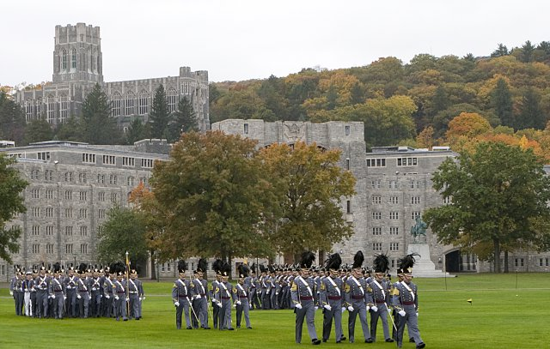

**Submission Guidelines**

Authors may make submissions by emailing their work to [report.hist.usma@gmail.com](mailto:report.hist.usma@gmail.com)

Requirements:

* Under 30 pages
* *Chicago Manual of Style* using footnotes
* Word document ( no PDFs)
* Not previously published or submitted in other academic journals
* Willing to edit

**Questions or comments?**

Please contact the Editor in Chief,

Cadet Rachel York, at:

[Rachel.York@usma.edu](mailto:Rachel.York@usma.edu)

**Report!**

The West Point Undergraduate Historical Review

Volume 9, Issue 1 (Spring 2018)

A Call for Papers

**Deadline: Oct 4th 2017**

**Report** is a historical journal dedicated to the publication of exceptional undergraduate research and analysis. In the past, we have published articles on a wide variety of subjects and historical time periods. We are simply looking for the best work offered by undergraduate historians. Submissions are peer reviewed by an interdisciplinary undergraduate staff with the assistance of faculty from the West Point History Department. The journal is published both online and in print during spring semester. Please visit the journal homepage at: <http://www.usma.edu/history/SitePages/report%20history%20journal.aspx>